How to upload a csv directory to your Yealink phone

**1) Press the OK button on your phone to get the IPv4 Address from the top of the display**

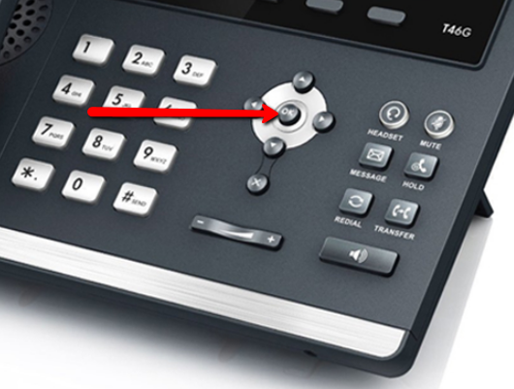

**2) Type this IPv4 Address into your web browser(Internet Explorer, Firefox or Chrome)then enter**



**3) Login to the phone: Username –admin**

**Password -(Your PBX password)**

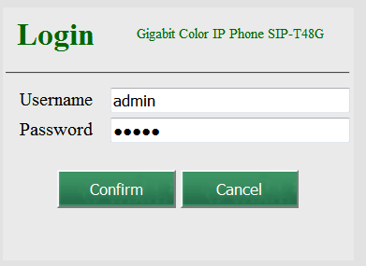

**4) Choose the Directory tab along the top**

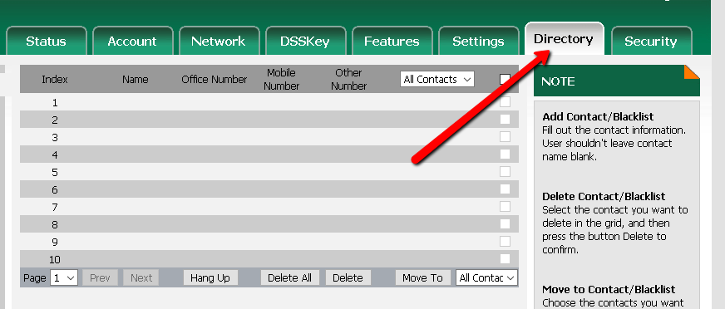

**5) Choose the (1) Browse option to find your .csv file and then the (2) Import CSV option near bottom of page**

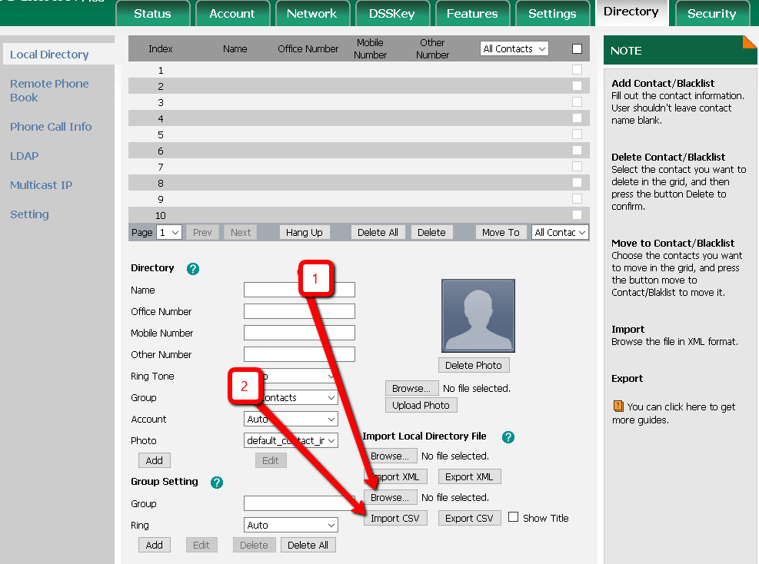

***Your csv file should be in the following format:***

***Full Name / Office Phone / Mobile Phone***

**6) Change the index from ignore to the corresponding title (1)– in this case Display Name, Office Number and Mobile number. Click on Import (2)**

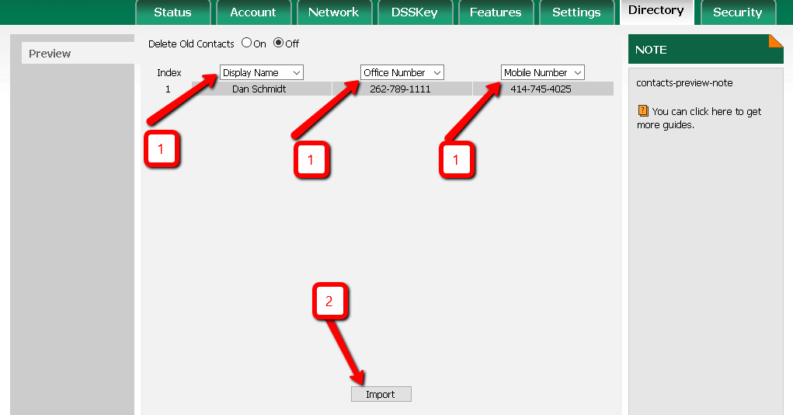

**7) Your entries will be saved and you can now Log Out.**

