How to change an extension name on your Yealink phone

**1) Press the OK button on your phone to get the IPv4 Address from the top of the display**

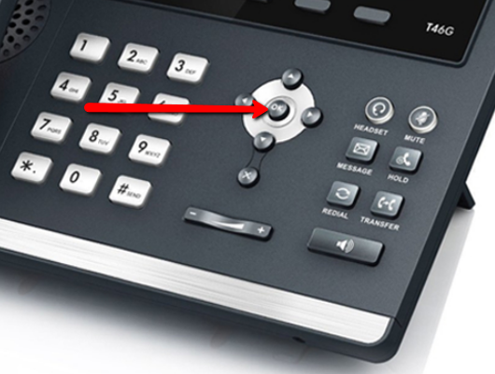

**2) Type this IPv4 Address into your web browser(Internet Explorer, Firefox or Chrome)then enter**



**3) Login to the phone: Username –admin**

**Password -(Your PBX password)**

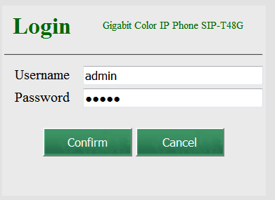

**4) Choose the DSS Key tab along the top**



**5) Set (1) to BLF and (2) to proper extension number and (3) is the name you want the label to show. (4) Hit Confirm to save it.**

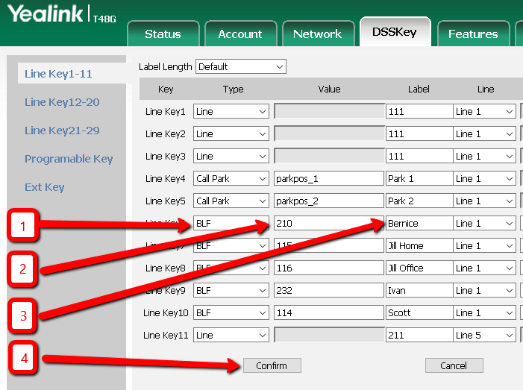

**6) Your entries will be saved and you can now Log Out.**

