

How to download your invoice

Go to https://pbx.dstech1.com
Login: (enter your login)
Password: DSTech21

Along the top row choose Accounting

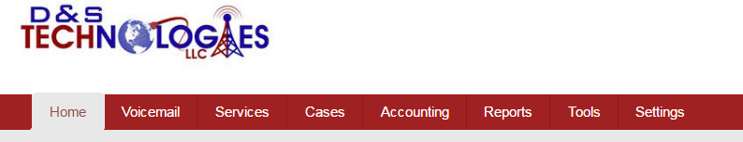

On the left choose Invoices
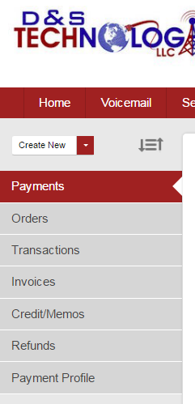

Choose which Invoice you want to download
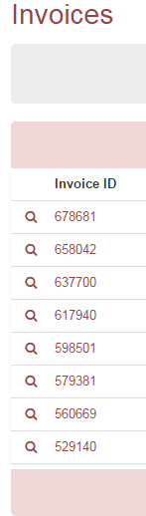

Under customer information choose download on the right
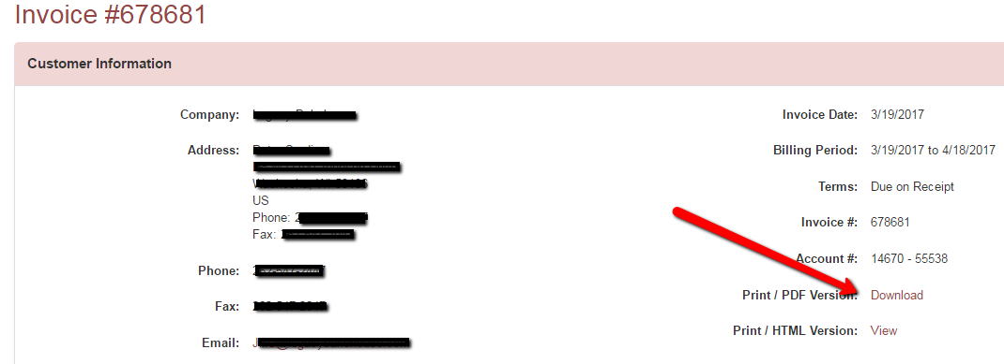

Questions D&S Technologies 262-789-1111

